RESPONSE TO THE CALL FOR PROPOSALS

Innovation Fund for Citizen Participation in Electoral Processes in Africa
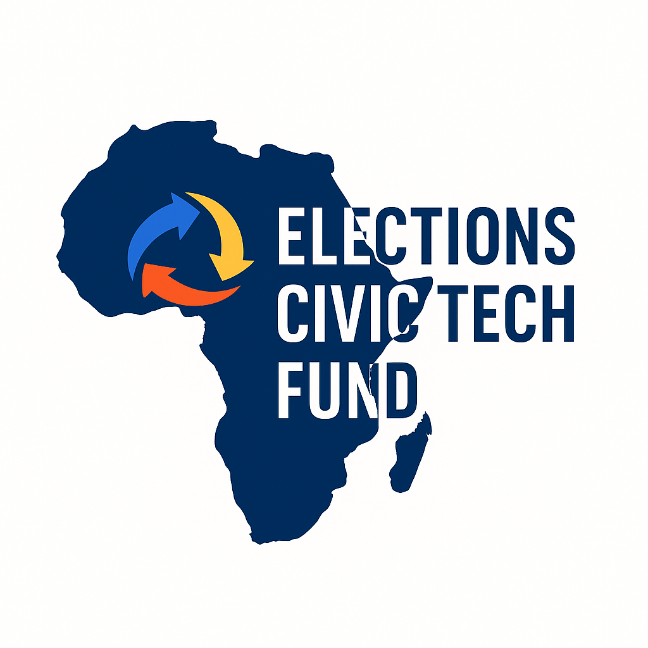

Election Civic Tech Fund
June 2025
Project description

The project description must not exceed twelve (12) pages.
Some of the information provided in this document may be requested again during the online form submission.

I. PROJECT INFORMATION
Project title | A clear, concise and representative title of the action
Project holder | Provide the legal name of the entity
Legal representative of the organisation /entity | Provide the name of the person responsible
Address | Provide location, phone number, email and country
Countries covered by the project | Indicate the country or countries covered by the project: (Fund countries: Somalia, Ethiopia, Sudan, South Sudan, Senegal, Benin, Burkina Faso, Guinea, Chad, Cameroon, Mauritania, Niger, Mali, Togo)
Project duration | In months (maximum 10 months)
Requested amount in euros | Indicate the total amount; express it in euros; between €10,000 and €25,000
Priority areas covered by the project | - D.1 – Electoral civic tech  Objective D1: Promote electoral civic technologies | - D.2 - Citizen engagement, inclusion and electoral process  Objective D2: Promote and strengthen youth and women's engagement and participation in electoral processes through technology.
 | - D.3 - Media and electoral information  Objective D3: Contribute to ensuring reliable and accessible electoral information | - D.4 - Legal framework  Objective D4: Contribute to strengthening a more transparent electoral legal framework that reflects citizens' aspirations

II. PROJECT SUMMARY
Clearly indicate the project name. It should reflect the objectives or expected outcomes of the project.

III. CONTEXT AND JUSTIFICATION
Explain why this project is relevant in your country or community context. Indicate the identified electoral challenges and the needs your project will address.

IV. GENERAL AND SPECIFIC OBJECTIVES

Describe the overall objective of the project in line with the theme of the Fund. List three to four specific objectives you aim to achieve during implementation.

V. TARGET GROUPS
Clearly identify the groups that will benefit directly or indirectly from the project. Emphasise youth, women or vulnerable communities, where applicable.

VI. DESCRIPTION OF MAIN ACTIVITIES
Present the main activities to be carried out to achieve your objectives. For each activity, specify: the title, a brief description, the duration, the methods used and the stakeholders involved.

VII. EXPECTED RESULTS AND INDICATORS
Indicate the tangible results expected at the end of the project implementation period. Formulate monitoring and evaluation indicators that are clear, measurable and realistic.

VIII THEORY OF CHANGE
Explain the intervention logic by specifying the links between proposed activities, expected results and medium- and long-term effects.

IX. INNOVATION, SUSTAINABILITY AND CONTINUITY
Explain what makes your project innovative. Indicate how the project's effects will be sustained beyond the Fund’s financing. Specify how communities or institutions will take ownership of the results.

X. RISKS AND MITIGATION
Identify at least three risks that could hinder the achievement of expected results as well as the measures planned to address them. The table below outlines the key risks identified, their potential impact level (low, medium, high), and the proposed mitigation strategies.

Identified risk | Potential impact | Likelihood | Mitigation
Example: Technical failures (platforms, digital tools) | Service interruption or data loss | High | Use robust open-source solutions, engage tech experts, and plan regular backups

XI. PROJECT RELEVANCE TO THE FUND’S PRIORITY AREAS
Explain how your project aligns with one or more of the Fund’s priority areas (D1, D2, D3, D4). Justify the link between your activities and the targeted area objectives.

XII. TEAM AND PARTNERS
Briefly present the project team (bios of team members), their qualifications and roles. Mention partners involved, the nature of their contribution and their complementarity.

XIII. PERSONAL DATA PROCESSING
Initiatives benefiting from this call for proposals agree that AfricTivistes may collect and process their information for the purposes of implementing this call until its conclusion, including in digital databases and waive any claim against AfricTivistes or its personnel in this respect.

VIX. CONTACTS
For any questions, please write to info@africTivistes.org by 9 July 2025.
Any incomplete application or any submission sent after 10 July 2025 at 23:59 GMT, or submitted by email, will be considered ineligible.

